# **ANALYZING THE DATA AND SOLVING THE QUESTIONS WITH HELP OF SQL**

-- **1. What is the gender breakdown of employees in the company?**

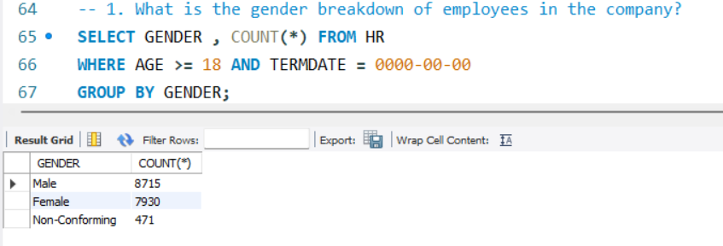

**-- 2. What is the race/ethnicity breakdown of employees in the company?**

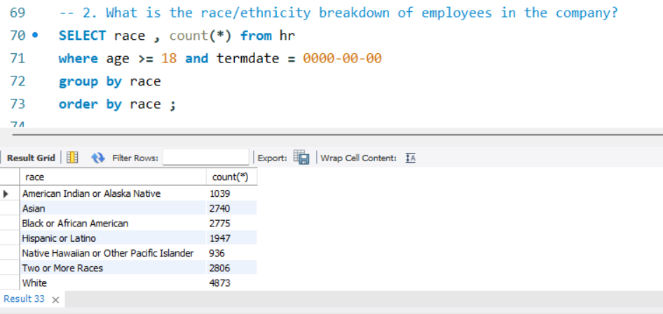

-- 3. What is the age distribution of employees in the company?

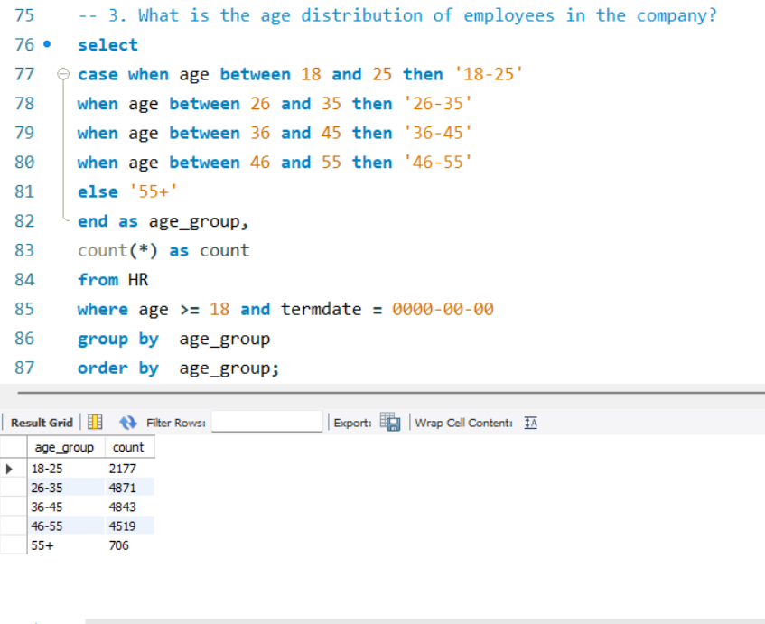

-**- 4. How many employees work at headquarters versus remote locations?**

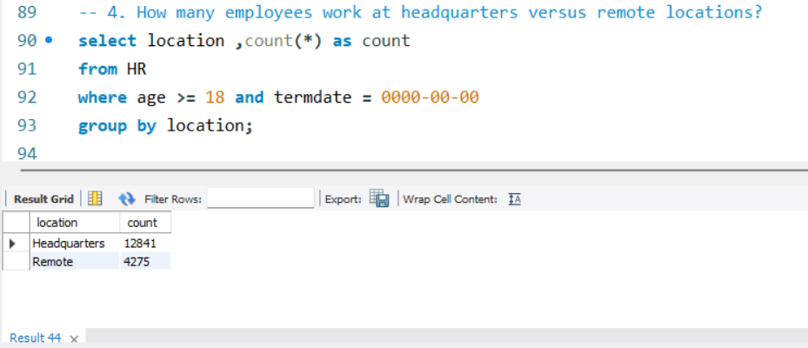

-- **5. What is the average length of employment for employees who have been terminated?**

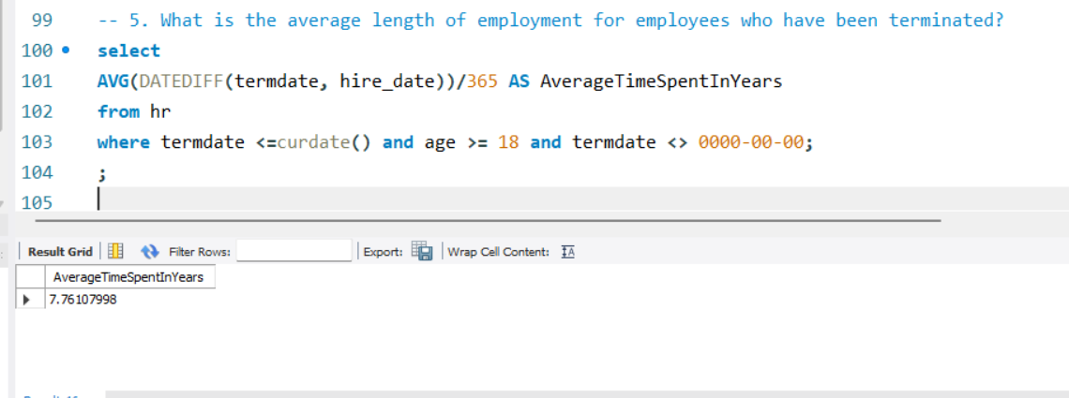

**-- 6. How does the gender distribution vary across departments and job titles?**

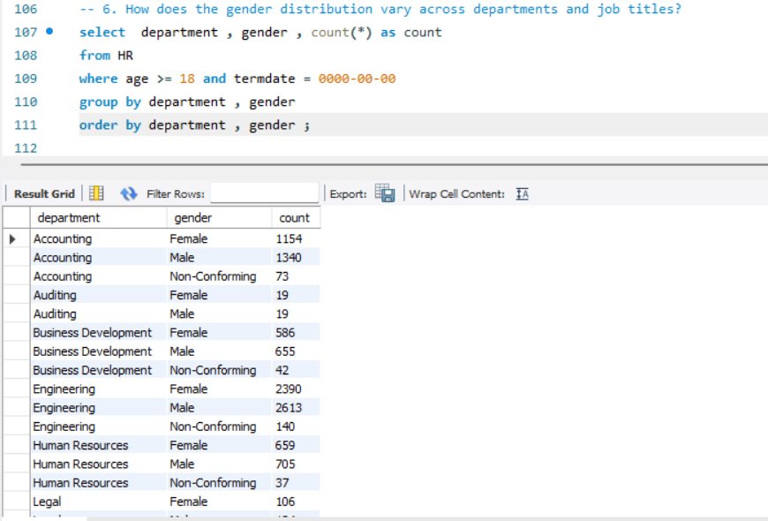

-- 7. What is the distribution of job titles across the company?

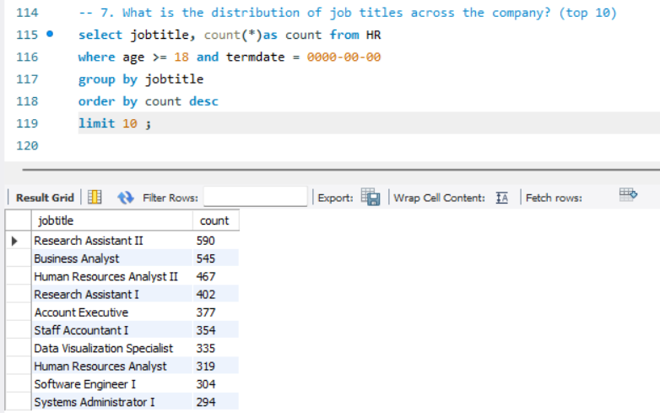

-- 8. Which department has the highest turnover rate?

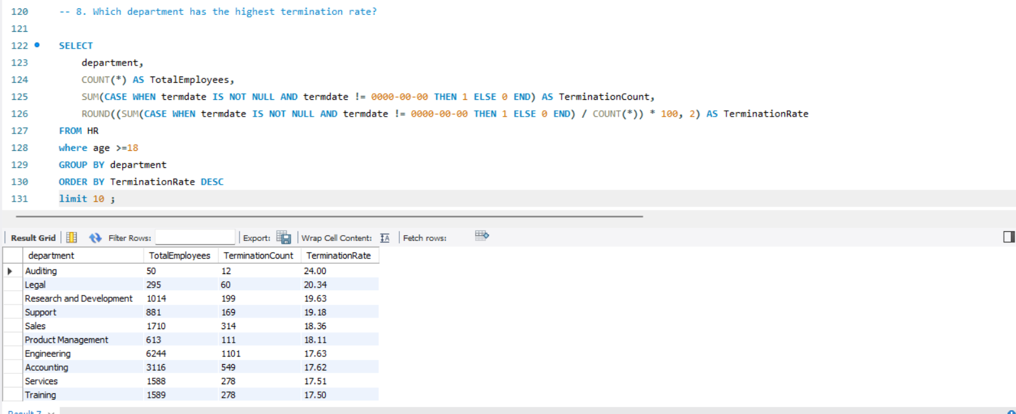

-- 9. What is the distribution of employees across locations by city and state?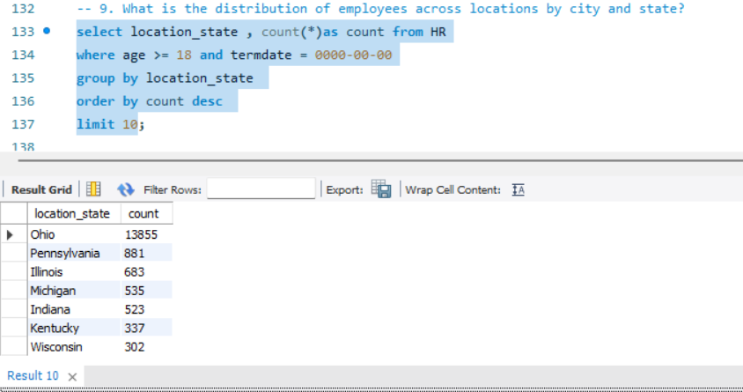

-- 10. How has the company's employee count changed over time based on hire and term dates?

